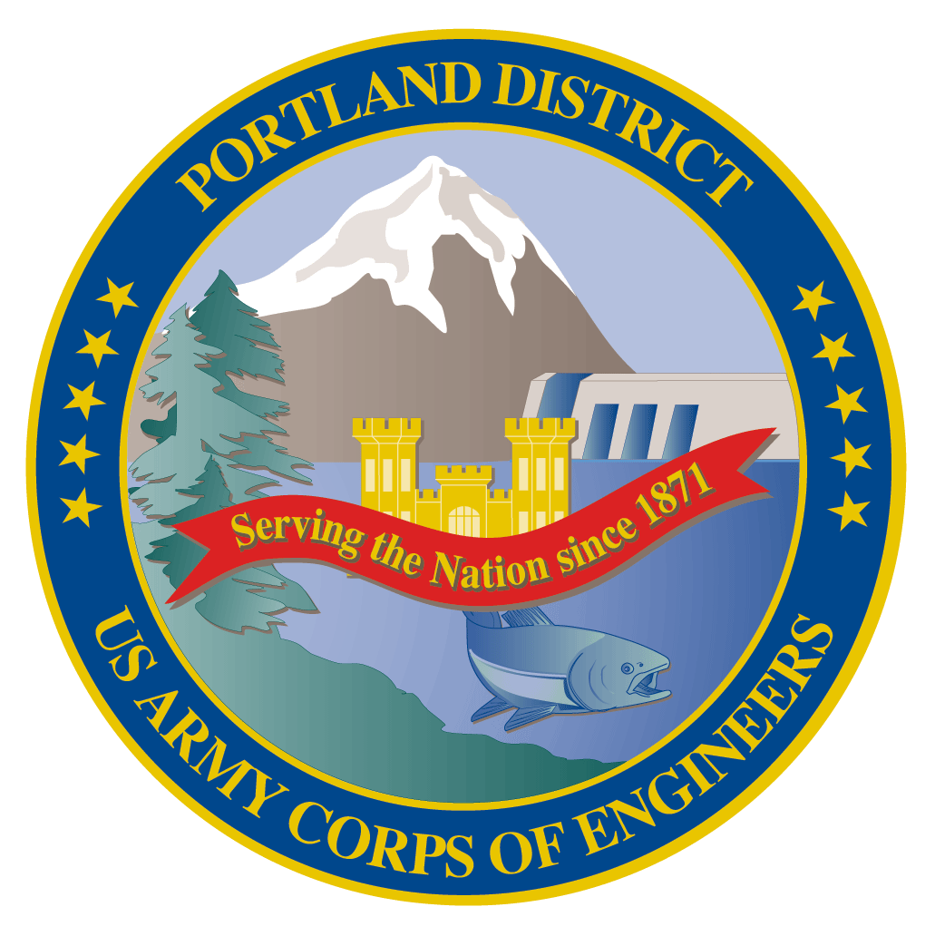Lower Columbia River Fish Facility Design Review Work Group (FFDRWG)

USACE, Portland District

# August 2021 Meeting Agenda

August 5, 2021 09:00-11:00

Join Meeting: <https://usace1.webex.com/usace1/j.php?MTID=m5c365c1bf762dad74cbaa2985e8e04fb>

Meeting password: FFDRwG2021!

*(*if using your phone for audio, log in through Webex and have the meeting call you)*

Join by phone (audio only, no Webex): (844) 800-2712 | Access Code: 199 571 1422

## Introductions

FFDRWG members:

**BPA**

*Scott Bettin

Kim Johnson

Siena Lopez-Johnston

*Christine Petersen

Greg Smith

Leah Sullivan

Ben Hausmann

**NOAA**

Blane Bellerud

Gabriel Brooks

*Trevor Conder

*Kinsey Frick

Claire McGrath

Josie Thompson

Logan Negherbon

**USFWS**

*Dave Swank

**States**

Erick Van Dyke (ODFW)

*Charles Morrill (WDFW)

**CRITFC/Tribes**

*Tom Lorz (CRITFC)

Blaine Parker (CRITFC)

Tom Skiles (CRITFC)

Laurie Porter (CRITFC)

*Greg Silver (CRITFC)

Casey Baldwin (CTCR)

Michael Karnosh (CTGR)

Lawrence Schwabe (CTGR)

Torey Wakeland (CTGR)

Aaron Jackson (CTUIR)

Ralph Lampman (YN)

**NPCC**

Leslie Bach

Kris Homel

**FPC**

*Erin Cooper

**PSMFC**

Alan Brower

Darren Chase

Roger Clark

Mark Leonard

Scott Livingston

Nicole Tancreto

Don Warf

**CENWD**

*Doug Baus

Tim Dykstra

Dan Feil

Mike Langeslay

Cindy Studebaker

*Lisa Wright

**CENWW**

Karl Anderson

Chris Peery

Marvin Shutters

Denise Griffith

**CENWP-OD**

*Andrew Derugin

Rebecca Cates

Jeanette Wendler

Bob Cordie

*Jeffrey Randall

*Scott Fielding

*Eric Grosvenor

*Michael Lotspeich

Laura Rickets

Tammy Mackey

Darren Gallion

*Nathan McClain

Robert Wertheimer

Karrie Gibbons

**CENWP-PM**

Jim Adams

*Eric Bluhm

Ian Chane

Jeff Hicks

Steve Sipe

Bob Winters

*Brad Eppard

David Griffith

Fenton Khan

Rachel Laird

*Jake Macdonald

Rich Piaskowski

Jon Rerecich

Ida Royer

David Trachtenbarg

Jeremiah Woodard

Erin Kovalchuk

**CENWP-ENC**

*Adam White

Brandt Bannister

Bridget Bell

Jonathon Brink-Roby

*Shari Dunlop

Laurie Ebner

Curtis Lipski

*Chris Motti

*Steve Schlenker

Max Wilson-Fey

Mehdi Roshani

## Action items from last meeting

* Max Wilson-Fey (ENC) will ask Laurie Ebner about the effects of deflectors and report back to FFDRWG
* Jacob Macdonald (NWP) will invite Laurie Ebner to next FFDRWG, reschedule for a time before Laurie retires for good
  + **FFDRWG field trip to Bonneville Dam spillway on 29-June accomplished both!**

## Topics for FFDRWG Discussion/Review/Coordination

* JDA adult lamprey passage improvements – Eric Bluhm (PM), Adam White (TL), Jacob Macdonald (FC)
  + Brief FFDRWG on results of 7/29 site visit with NOAA to review water supply options (White/Schlenker)
* TDA adult lamprey passage improvements – Eric Bluhm (PM), Adam White (TL), Jacob Macdonald (FC)
  + LPS design guidelines:
    - Hattie Zobott, Christopher C. Caudill, Matthew L. Keefer, Ralph Budwig, Kinsey Frick, Mary Moser, and Steve Corbett. 2015. Design Guidelines for Pacific Lamprey Passage Structures. Study Code LMP-P-13-1.
    - Pacific Lamprey Technical Workgroup. 2017. Practical guidelines for incorporating adult Pacific lamprey passage at fishways. June 2017. White Paper. 47 pp + Appendix. Available online: <https://www.fws.gov/pacificlamprey/mainpage.cfm>
    - Any other guideline/criteria we should consider?
* BON1 adult lamprey passage improvements – Bob Winters (PM), Adam White (TL), Jacob Macdonald (FC)
  + Brief FFDRWG on results of 7/26 PDT site visit to Bradford Island entrance
    - Location for collection box (White)
    - Potential gravity-fed water source (White/Derugin)

## Written project updates

* JDA turbine rehab – Steve Sipe (PM), Curtis Lipski (TL), Jon Rerecich (FC)
* TDA AWS Debris Management– Erin Kovalchuk (PM), Mehdi Roshani (TL), Jon Rerecich (FC)
* BON Second Powerhouse FGE – Jim Adams (PM), Bridget Bell (TL), Jon Rerecich (FC)
* JDA adult lamprey passage improvements – Eric Bluhm (PM), Adam White (TL), Jacob Macdonald (FC)

* TDA adult lamprey passage improvements – Eric Bluhm (PM), Adam White (TL), Jacob Macdonald (FC)
* BON1 adult lamprey passage improvements – Bob Winters (PM), Adam White (TL), Andrew Derugin (FC)
* BON2 adult lamprey passage improvements – Bob Winters (PM), Andrew Derugin (TL), Andrew Derugin (FC)

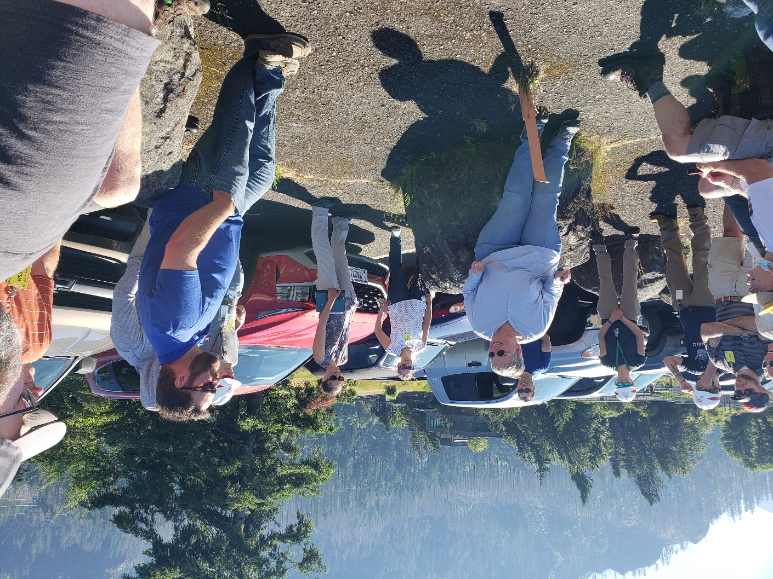

Fish Facility Design Review Work Group (FFDRWG)

USACE, Portland District

Project Update

Date Prepared/Updated: 2021-04-01

# JDA Turbine Rehab

|  |  |
| --- | --- |
| Project Identifier: | P2 # |
| Project Manager (PM): | Steve Sipe (CENWP-PMF-P)  *Steven.C.Sipe@usace.army.mil* |
| Technical Lead (TL): | Curtis Lipski (CENWP-ENC-HD)  *Curtis.L.Lipski@usace.army.mil* |
| FFDRWG Coordination (FL): | Jon Rerecich (CENWP-PME)  *Jonathan.G.Rerecich@usace.army.mil* |

## Project Description

The purpose of this project is to address reliability concerns and maximize production of hydroelectric power at JDA, which includes electrical energy production and electrical grid ancillary services while at the same time, improving survival of fish passing through the turbines. Maximum production of hydroelectric power at JDA will be realized through increased reliability and increased efficiency. Reliability improvements will be realized through a combination of replacement and refurbishment of powertrain equipment to include, but not limited to, turbine runners, shafting, generators, isophase bus, breakers, switches, and transformers. Efficiency improvements will be realized through increased turbine efficiencies associated with new turbine runners and other modifications to the turbines.

The purpose of this project is also to increase survival of turbine passed fish. Increased survival of turbine passed fish will be realized through developing state-of-art hydroelectric turbines to obtain improved fish passage survival through the turbines. The design of the state-of-the-art turbines will be an iterative and collaborative process that focuses on fish-friendly design features and criteria. This iterative and collaborative design process will be similar to the ongoing Ice Harbor L&D turbine runner replacement design and upcoming McNary L&D turbine runner replacement in NWW. Phase 1A recommendations include replacing up to 14 units with combination fixed blade & adjustable blade to obtain improved fish passage survival through the turbines.

## Project Schedule

|  |  |  |
| --- | --- | --- |
| Phase 1 Short Term Schedule | Start | Finish |
| 30% DDR/P&S review | 3/12/2020 | 4/1/2020 |
| 60% DDR/P&S review | 8/28/2020 | 9/18/2020 |
| 90% DDR/P&S review | 9/21/2021 | 2/18/2022 |
| BCOES review | 1/24/2022 | 11/11/2022 |

|  |  |
| --- | --- |
| Overall Schedule Milestones | Date |
| Contract award | October 2024 |
| Collaborative design process Model testing | 2024-2029 |
| First unit installation | 2031-2033 |
| Unit installation complete | 2040-2045 |

## Current Status

* Final VE study report due Feb. 19, 2021
* The 1:25 scale physical observational turbine model rehab and relocation is complete. The model will be used to inform the development of the Phase 1 Plans and Specifications package, to document the hydraulic conditions that affect the biological performance of the existing JDA turbines, and to support the collaborative and iterative design process in Phase 2. ERDC baseline model validation testing with the existing runner has been scheduled for last week and this week. Baseline model data collection for Test Series 1 will be occurring until May 2021 at which time ERDC is scheduled to transition back to McNary. This task includes preparation of a data report documenting the runs performed, results, conclusions, and recommendations. Runner evaluation tests will need to carry over to Test Series 2 (not yet scoped), which is expected to occur in late 2021 or early 2022.
* Tailrace flow patterns have been validated in the 1:45 JDA general model and in a CFD model. Model runs will commence after further HAC modeling is complete and preliminary options for the turbine mix are established. The focus of the tailrace modeling will be to assess juvenile egress and conditions for adult approach to the fish ladder entrances.

## Topics for FFDRWG Review/Coordination

None currently.

Fish Facility Design Review Work Group (FFDRWG)

USACE, Portland District

Project Update

Date Prepared/Updated: 2021-06-03

# TDA Backup AWS Debris Management EDR

|  |  |
| --- | --- |
| Project Identifier: | P2 # |
| Project Manager (PM): | Erin Kovalchuk (CENWP-PMF)  *Erin.H.Kkovalchuk@usace.army.mil* |
| Technical Lead (TL): | Mehdi Roshani (CENWP-ENC)  *Mehdi.Roshani@usace.army.mil* |
| FFDRWG Coordination (FC): | Jon Rerecich (CENWP-PME)  *Jonathan.G.Rerecich@usace.army.mil* |

## Project Description

This project is to evaluate alternatives to remove debris from The Dalles Dam Auxiliary Water Supply (AWS) trash rack. Debris build-up on the rack currently causes high head differential across the rack. Fish Unit Rehab, potentially starting in the year 2024, requires the AWS backup system to operate during the rehab to provide adequate flow for fish attraction. Fish Unit Rehab duration is one year per unit for a total of two years. Long term use of the backup AWS system will be part of the alternatives evaluation.

## Project Schedule

|  |  |  |
| --- | --- | --- |
| **Milestone** | **Start** | **End** |
| **Criteria and Constraint Report** | 4/19/2021 | 8/6/2021 |
| **Value Management** | 8/9/2021 | 8/20/2021 |
| **Alternative Evaluation Report** | 8/23/2021 | 12/10/2021 |
| **Draft Final Report** | 12/13/2021 | 4/1/2022 |
| **ATR** | 3/21/2022 | 4/1/2022 |
| **Final Report** | 4/4/2022 | 5/27/2022 |
| **Closeout** | 5/30/2022 | 6/3/2022 |

## Current Status

Working on the Criteria and Constraints for the EDR.

## Topics for FFDRWG Review/Coordination

None currently. PDT will solicit FFDRWG participation during the Engineering Design Report (EDR) process.

Fish Facility Design Review Work Group (FFDRWG)

USACE, Portland District

Project Update

Date Prepared/Updated: 2021-03-30

# BON Second Powerhouse FGE

|  |  |
| --- | --- |
| Project Identifier: | P2 # |
| Project Manager (PM): | Jim Adams (CENWP-PMF)  *James.R.Adams@usace.army.mil* |
| Technical Lead (TL): | Bridget Bell (CENWP-ENC)  *Bridget.M.Bell@usace.army.mil* |
| FFDRWG Coordination (FL): | Jon Rerecich (CENWP-PME)  *Jonathan.G.Rerecich@usace.army.mil* |

## Project Description

Steel plates were installed in all units in the A and B gatewells to restrict flow. During routine inspections, however, it became apparent that the anchoring system for the steel plates was inadequate. In effect, the nuts and anchoring bolts holding down the plates had come lose, posing the risk that the plates could detach and potentially take out a unit. All flow restriction plates were removed from the units.

A concrete corbel will be installed in the same location as the flow control plates with the design goal to achieve similar gatewell hydraulic conditions as the flow control plates. This new concrete corbel has been designed to meet the flow criteria established and tested for the previous flow restrictor plates to meet the hydraulic and biological goals.

## Project Schedule

Awarded 21 December 2020 to Northbank Civil and Marine. Notice to proceed 29 December 2020.

|  |  |  |  |  |
| --- | --- | --- | --- | --- |
| CLIN | Status | Description | Award/Exercise Date | Construction Execution Window |
| 1 | Mandatory | Mobilization/Demobilization | December 2020 Award |  |
| 2 | Mandatory | Unit 15 Construction | December 2020 Award | February 2021-April 2021 |
| 3 | Optional | Second Mob/Demob and Unit 11 Construction | Sept. 30, 2021 | Dec 2021-Feb 2022 |
| 4 | Optional | 2 Additional Units | Sept. 30, 2021 | Extend through May 2022 |
| 5 | Optional | 2 Additional Units | Nov. 30, 2021 | Extend through August 2022 |
| 6 | Optional | 2 Additional Units (Unit 18 + 1 more Unit) | Nov. 30, 2021 | Extend through February 2023 |

## Current Status

* Construction in unit 15 is underway and on track. Unit 15 is on the outage schedule March 1-April 20. The contract states the unit must be completed by April 15th.
* Hydraulic Testing Spring 2021 – During March contract negotiations with NWP, the A/E contractor expressed concerns in meeting the testing deadline and deliverables due to procurement of equipment, preparation/calibration of equipment, and staffing limitations. Hydraulic testing will not occur this year.
* Hydraulic tests will be needed next spring to meet the upper 1% test range of 18.0-18.5 kcfs.
* Impacts to the B2FGE concrete work contract are being evaluated. The concrete work will be delayed by one year.
* Rerecich owes Lorz a beer.

## Topics for FFDRWG Review/Coordination

None currently.

Fish Facility Design Review Work Group (FFDRWG)

USACE, Portland District

Project Update

Date Prepared/Updated: 2021-08-03

# JDA adult lamprey passage improvements

|  |  |
| --- | --- |
| Project Identifier: | P2 # 492402 |
| Project Manager (PM): | Eric Bluhm (CENWP-PM-FP)  *Eric.V.Bluhm@usace.army.mil* |
| Technical Lead (TL): | Adam White (CENWP-ENC)  *Adam.J.White@usace.army.mil* |
| FFDRWG Coordination (FC): | Jacob Macdonald (CENWP-PME)  *Jacob.Macdonald@usace.army.mil* |

## Project Description

1. Modify NFL LPS to increase the capacity and reliability of the system

*This is a fish safety/health issue, and the upgrade needs to happen. Current water supply is insufficient so tank cannot be installed without upgraded water supply.*

1. gravity-fed water supply or alternative, more reliable pump configuration.
2. larger collection box
3. South fish ladder entrance improvements (rounded crest, slot cover/filler)

*Caps cannot be added to South Ladder entrance weir due to FPP submergence criteria, so the weir needs to be modified more extensively to provide rounded weir crests and guide slot covers.*

## Project Schedule

Design: FY 2021 – FY 2022

30% DDR – July 2021

60% DDR – October 2021

90% DDR – April 2022

BCOES – May 2022

Construction: December 2022 - March 2023

Evaluation/Closeout: FY 2023

## Current Status

30% DDR review comments being evaluated. Site visit with NOAA on 7/29 to review water supply options.

## Topics for FFDRWG Review/Coordination

Brief FFDRWG on results of 7/29 site visit with NOAA to review water supply options.

Fish Facility Design Review Work Group (FFDRWG)

USACE, Portland District

Project Update

Date Prepared/Updated: 2021-08-03

# TDA adult lamprey passage improvements

|  |  |
| --- | --- |
| Project Identifier: | P2 # 492403 |
| Project Manager (PM): | Eric Bluhm (CENWP-PM-FP)  *Eric.V.Bluhm@usace.army.mil* |
| Technical Lead (TL): | Adam White (CENWP-ENC)  *Adam.J.White@usace.army.mil* |
| FFDRWG Coordination (FC): | Jacob Macdonald (CENWP-PME)  *Jacob.Macdonald@usace.army.mil* |

## Project Description

Design and install a lamprey collection system at the east fish ladder entrance. Provide a ramp (or multiple) for lamprey to swim out of the transition pool and into a collection box located below the upper segment of the fish ladder.

“Expand network of Lamprey Passage Structures (LPSs) to bypass impediments in existing fish ladders (Lamprey Passage Structures). Ramp-like flume structures would be installed or modified in fish ladders at Bonneville, The Dalles, and John Day dams to guide adult lamprey out of fish ladders and into parallel systems for volitional passage or collection for upstream transport or passage studies. The LPSs would use independent water sources (pumps or gravity flow systems) and may be placed in various locations within fish ladders, such as collection channels, junction pools, and auxiliary water supply channels. New structures may be installed at Bonneville Dam’s Bradford Island and Washington Shore fish ladders, The Dalles Dam’s east fish ladder, and/or John Day Dam’s south fish ladder. At John Day Dam, the existing lamprey passage structure on the north fish ladder may be extended from the tailrace deck to the forebay”

**-January 2020 CRS BA § 2.5, pg. 2-85*.***

## Project Schedule

Design: FY 2021 – FY 2022

30% DDR – August 2021

60% DDR – November 2021

90% DDR – April 2022

BCOES – June 2022

Construction: December 2022 - March 2023

Evaluation/Closeout: FY 2023

## Current Status

30% review is still open for comments. Preferred design includes gravity-fed water from behind picketed leads near count station.

## Topics for FFDRWG Review/Coordination

Ask FFDRWG for any other sources of LPS design guidelines/criteria. The PDT is aware of Zobott et al. (2015).

Fish Facility Design Review Work Group (FFDRWG)

USACE, Portland District

Project Update

Date Prepared/Updated: 2021-08-03

# BON1 adult lamprey passage improvements

|  |  |
| --- | --- |
| Project Identifier: | P2 # 492400 |
| Project Manager (PM): | Bob Winters (CENWP-PM-FP)  *Robert.Winters@usace.army.mil* |
| Technical Lead (TL): | Adam White (CENWP-ENC)  *Adam.J.White@usace.army.mil* |
| FFDRWG Coordination (FC): | Jacob Macdonald (CENWP-PME)  *Jacob.Macdonald@usace.army.mil* |

## Project Description

The project scope is divided into three parts:

### Entrance Modifications

Modify the B-branch fish ladder entrance to improve lamprey passage. This includes a variable-width entrance weir with rounded edges, guide slot fillers or covers to aid lamprey passage along the walls, and bollards on the channel floor for hydraulic refuge.

### Lamprey Collection

Provide an alternate route for lamprey entering the B-branch of the Bradford Island fish ladder. Fish would climb up a flume structure to a holding tank on the deck of the dam and be transported upstream by Tribal fisheries personnel. This will be designed so that in the future we could extend the system to provide volitional passage to the Bonneville forebay. This PDT will have to decide if the future volitional passage system will terminate on the north or south side of Bradford Island, which will determine where we place the collection box for the current scope of work.

### Serpentine Section Extensive Minor Mods

Upgrade the serpentine section of the Bradford Island fish ladder to improve lamprey passage by rounding corners, providing refuge boxes, and lamprey orifices.

## Project Schedule

Design: FY 2021 – FY 2022

30% DDR – July 2021

60% DDR – October 2021

90% DDR – January 2022

BCOES – March 2022

Construction: December 2022 - March 2023

Evaluation/Closeout: FY 2023

## Current Status

PDT site visit on 7/26. PDT is evaluating comments on 30% DDR and beginning work on 60% DDR (due in October).

## Topics for FFDRWG Review/Coordination

Brief FFDRWG on results of 7/26 PDT site visit to Bradford Island entrance

* + - Location for collection box
    - Potential gravity-fed water source

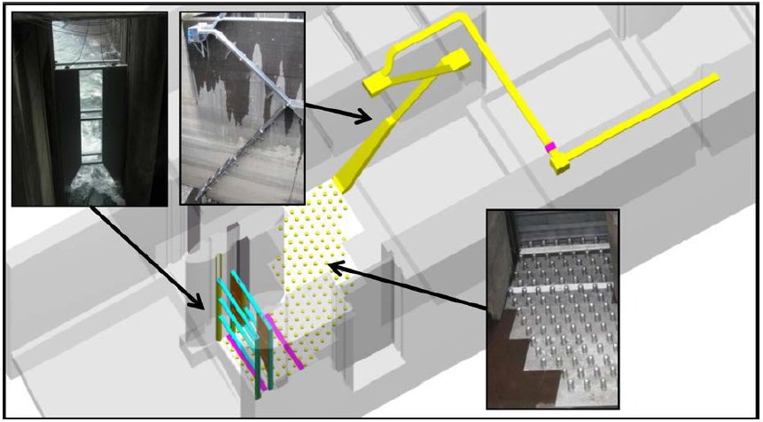

*Cascades Island entrance improvements (2009)*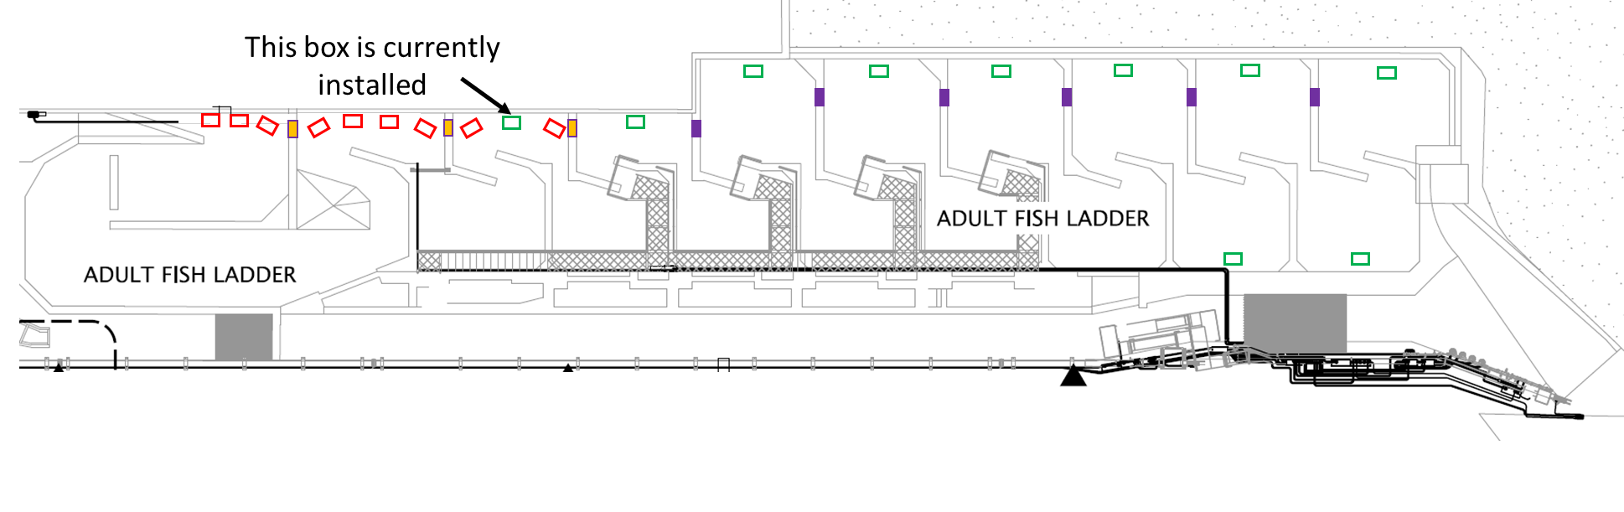

Fish Facility Design Review Work Group (FFDRWG)

USACE, Portland District

Project Update

Date Prepared/Updated: 2021-08-03

# BON2 adult lamprey passage improvements

|  |  |
| --- | --- |
| Project Identifier: | P2 # 492401 |
| Project Manager (PM): | Bob Winters (CENWP-PM-FP)  *Robert.Winters@usace.army.mil* |
| Technical Lead (TL): | Shari Dunlop (CENWP-ENC)  *Shari.L.Dunlop@usace.army.mil* |
| FFDRWG Coordination (FC): | Jacob Macdonald (CENWP-PME)  *Jacob.Macdonald@usace.army.mil* |

## Project Description

Full redesign of control section (DDR, P&S, Construction).

2020 CRS BA Chapter 2: Proposed Action (pg.2-85): “This measure would modify the serpentine-style flow control sections of Bonneville Dam’s Washington Shore and Bradford Island fish ladders, converting them to Ice Harbor-style vertical slot with submerged orifices configurations. This would improve passage conditions for adult lamprey and likely reduce stress and delay for adult salmon, steelhead, and bull trout. All full-duplex passive integrated transponder (PIT) arrays currently located in the control sections of these ladders would be replaced in kind or improved to maintain or enhance current levels of detection of PIT-tagged anadromous fish.

## Project Schedule

Design: FY2021-FY2024

Construction: Winter 2024/2025

Evaluation/Follow-on: FY2025-FY2026

Closeout: FY 2027

Preliminary Milestones:

* Project Kick-Off: ~ August 2021 (FY21 Q4)
* 30% DDR: ~ December 2021 (FY22 Q1) **\*FFDRWG review ~Jan 2022**
* 60% DDR: ~ April 2022 (FY22 Q3) **\*FFDRWG review ~May 2022**
* 90% DDR: ~ July 2022 (FY22 Q4) **\*FFDRWG review ~Aug 2022**
* Draft-Final: ~ September 2022 (FY23 Q1) **\*FFDRWG review ~Oct 2022**
* [Start P&S after 90% DDR DQC is complete, ~August 2022]

## Current Status

Ongoing preliminary hydraulic work leading to a site-specific cost estimate ~October 2021.

## Topics for FFDRWG Review/Coordination

None currently.

